Computer Vision
Assignment 1 Report:
Ahmad Yasser Mohammad Salaheldin Hamad (ID:9074)
Moamen Talaat (ID:9103)

Part 1 (Image Cartoonfying):
The objective of this section is to apply a sequence of filters in order to add a cartoonish effect to a given image.
The image is processed as a black and white image in preparation for the Laplacian edge filter that requires single channel images to operate. The median filter is first done. The goal from this filter is to remove any background noise while keeping the edges sharp enough. Afterwards, the output from the Laplacian filter is calculated. The output is the values of the pixel intensities that uniquely distinguish the image and gives it its structural boundaries. Given the varying brightness levels from the Laplacian filter, a binary threshold is completed to force each and every edge to be black and the background to be white, creating a simple sketch of the outlines of the edges in the image.
The original image is used once again for the bilateral filter. Unlike standard blurring filters (which average out all values of neighboring pixels), a bilateral filter is able to successfully distinguish flat, smooth regions, while maintaining the integrity of the edges. However, a single iteration of a large bilateral filter takes a considerable time frame, smaller filters are applied multiple times, resulting in the same output.
To conclude the cartoonish effect, a bitwise and operation is utilized. If the value of the given pixel from the mask is greater than 0, its actual intensity value is considered. If it is exactly 0, the original image intensity value is completely ignored, forcing the output at the given pixel intensity to be strictly a zero (purely black).
Threshold Function:
To make the edges that are outputted from the Laplacian filter be more or less hand drawn sketches, a binary threshold has to be enforced. If a pixel’s intensity is greater than or equal to 100, its value is automatically assigned as 255 (white). Given that the flag THRESH_BINARY_INV is used, any pixel scoring or exceeding 100 is assigned a 0 and anything lower is assigned 255.
Impact of the Kernel Size:
The kernel size defines how thick the grid will be while looking for edges. Smaller kernel sizes mean higher sensitivity. They only consider immediate neighbors of a pixel. This leads it to consider small details. It is also highly vulnerable to noise. Larger kernel sizes mean broader strokes. A wider average of surrounding area is considered, ignoring tiny variations and is only triggered from massive color shifts between pixels. It drops fine details in this process.
Testing with Varying Images:
A single set of parameters was found to work well for multiple images in this task. As the goal of the assignment is to destroy fine details to make flat regions flatter and strong edges thicker, similar patterns across different images can be found. Using a bilateral filter also helps standardize such a process.
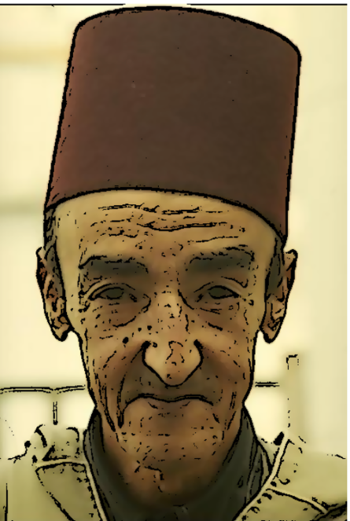
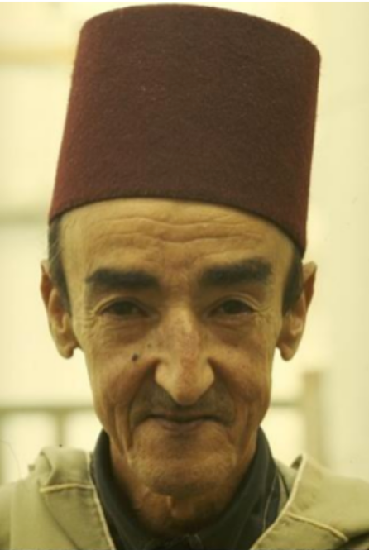
Test Images and Outputs:



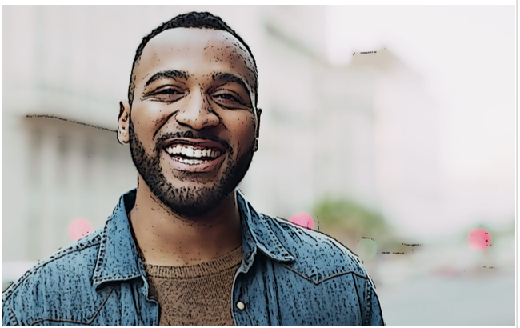

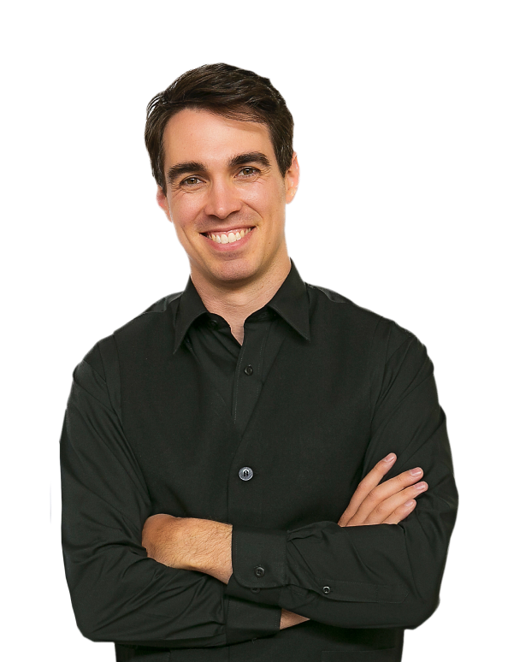
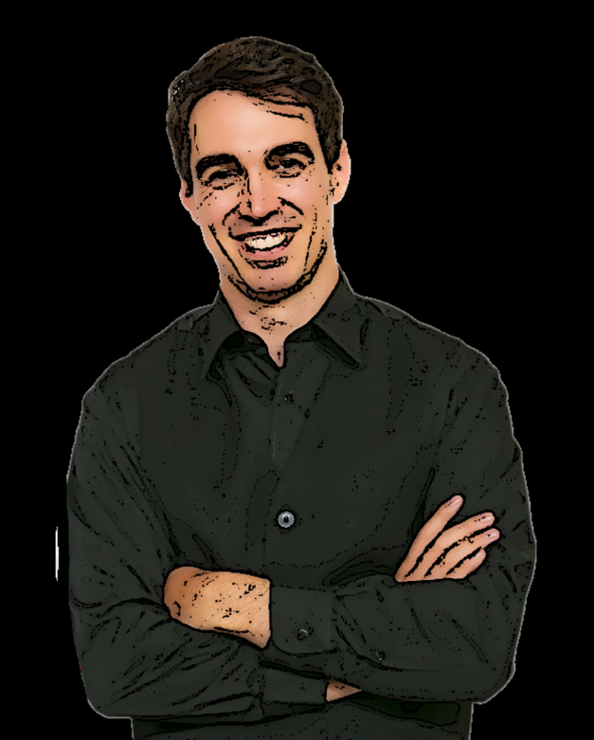

Part 2 (Lane Detection using Hough Transform):
Objective
The goal of this project is to detect lane lines and street borders in a road image using manual implementation of the Hough Transform. The steps include preprocessing the image, detecting edges, selecting a region of interest (ROI), performing Hough Transform, detecting peaks, applying non-maximum suppression, and finally overlaying the detected lines on the original image.
Preprocessing of image
It was made by changing the RGB image to a grayscale one to reduce computational complexity then smoothing using a 2D median filter
Edge Detection
It was made using Canny edge detector which is used rather than sobel as it produce a thinner edges which is better for lane detection and it can detect a threshold
Region of interest
Was made by making a polygon and then masking it on the edge detected image to highlight only the wanted areas in the image
Manual Hough Transform
Was made by using the equation of rho = x cos(theta) + y sin(theta) and then using accumulator to determine the number of votes for each rho index which is used for a candidate to be a straight line

Peak detection
The peak detection was made to detect which lines candidates should be taken as not all lines should be considered important
Non Maximum suppression
Not all the lines should be important even if they are strong as very near lines should be neglected to avoid a lot of noises
Final Output
The final thing in the code is to get the final photo after detecting the lanes which can be make by bitwising the line image made after Hough Transform with the masked image which will get the output of the lane used for the Cars to know the lane to move on
Example 1
Original image
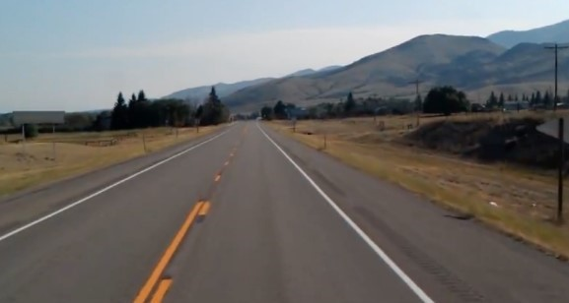

Image after using the median and grayscaling filter
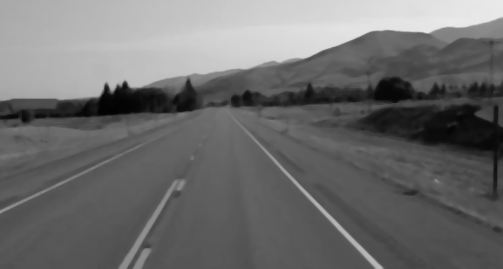

Edge detecting using canny
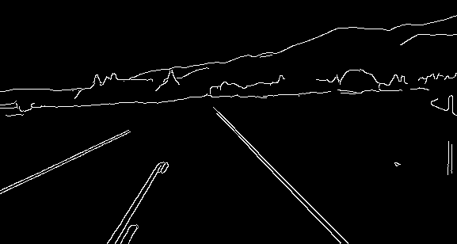

ROI
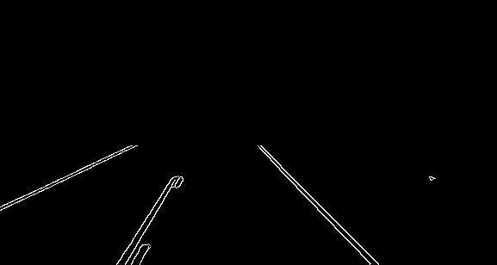

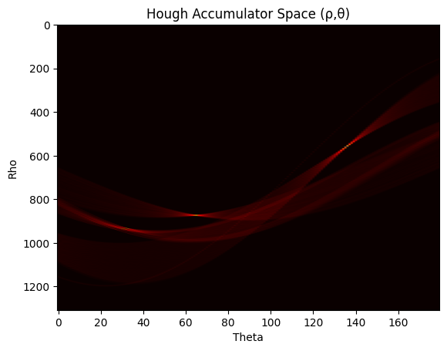
Final output
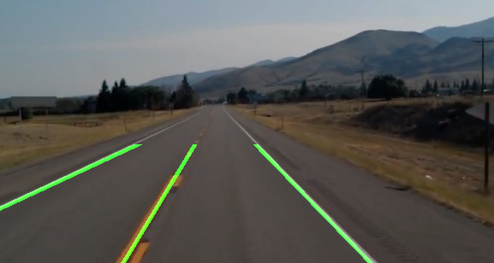

Example 2
Original image
